**Personal Portfolio Template**

Group 77

Mingze Dai, N9881093

EatChiliDaily

**Artefact 1** – Logical and Physical diagrams

Logical diagram is a generic abstraction of the architecture pattern. And physical diagram is the web based designed application on physical perspective includes 3 tiers architecture which allow to add different physical actions which interact with each of these layers and show the process of how it works on reality. And basically, we can add any details we want in this diagram such as data flow, data process location and progress rate

Logical diagram makes sure the software design is easier to understand and physical diagram helps us make the design process clearer and provide the thoughts of how to fuel the whole process

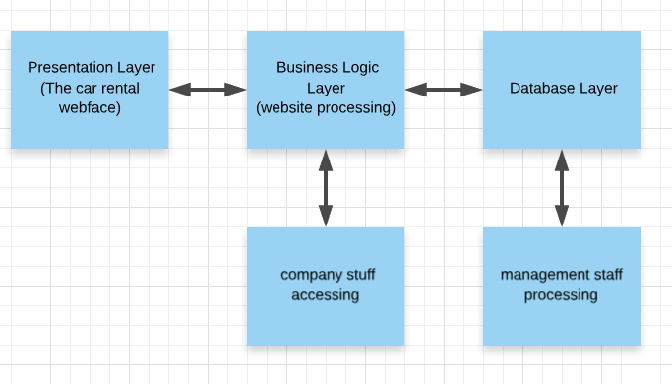

(Logical diagram)

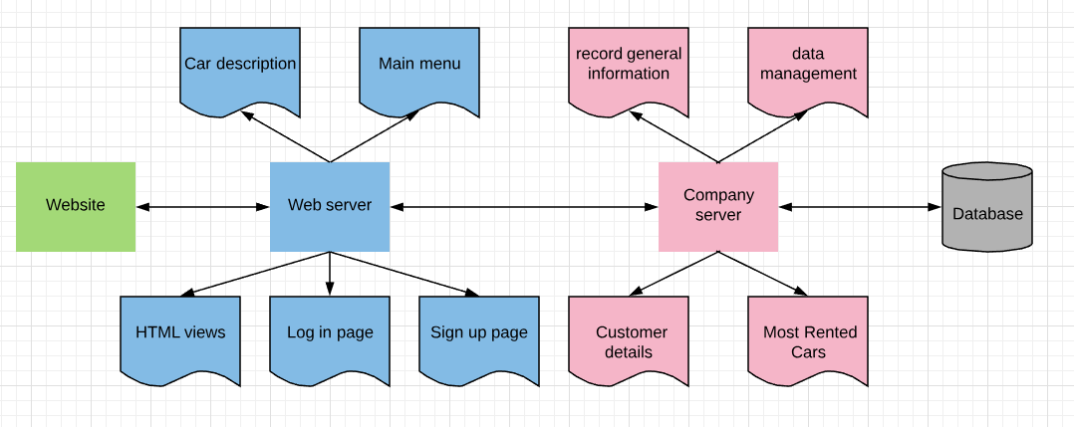

(Physical diagram)

**Artefact 2** – User interface design

UI design is a rough idea of how the web will look like in the end and it provides a brief and rough view of how the web should look like and gives developer a frame to achieve.

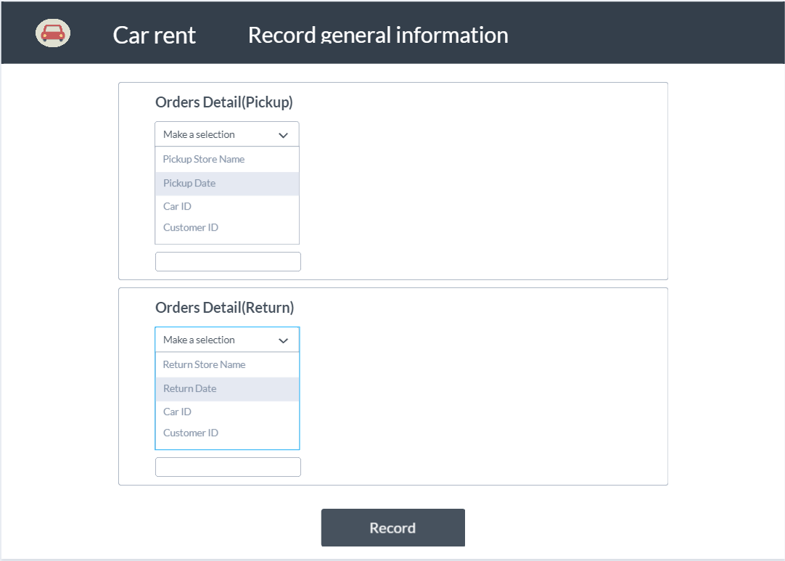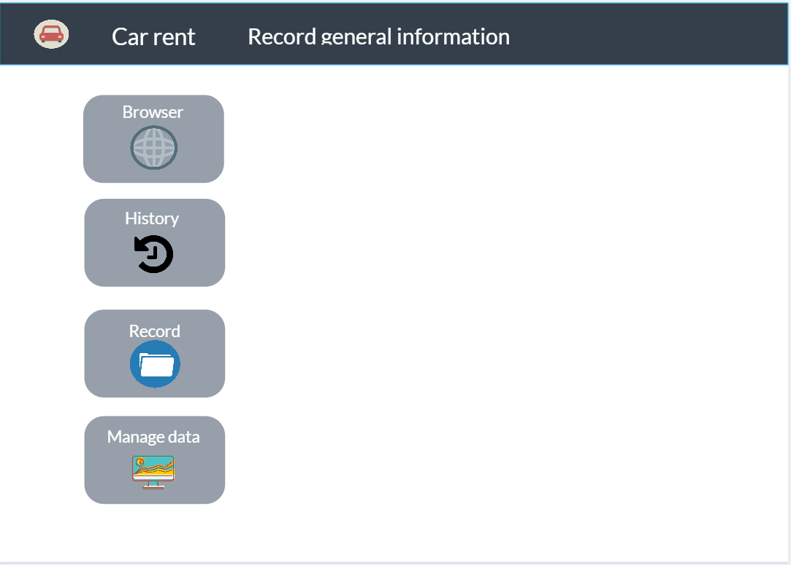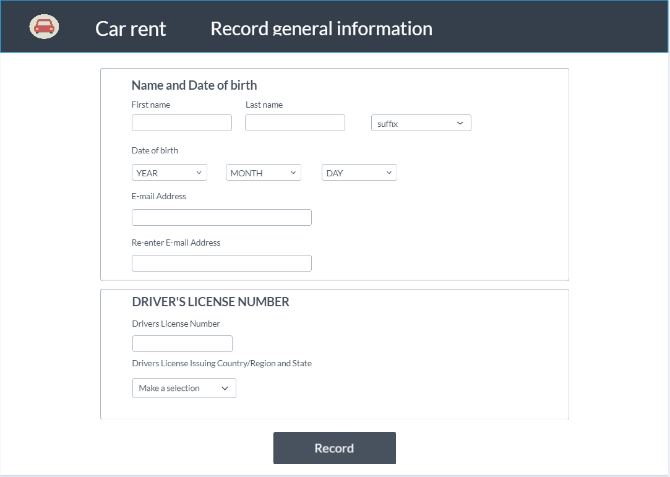

**Artefact 3** – object diagram

An object diagram focuses on the attributes of a set of objects and how those objects relate to each other. In this object diagram below, there are four instances, which are:

1. Car with MakeName Land Rover from Class Car

2. Order with ID 3 from Class Order

3. Customer with ID 10014 from Class Customer

4. Store with ID 1 from Class Store

It helps developer get a high-level overview of the system developing

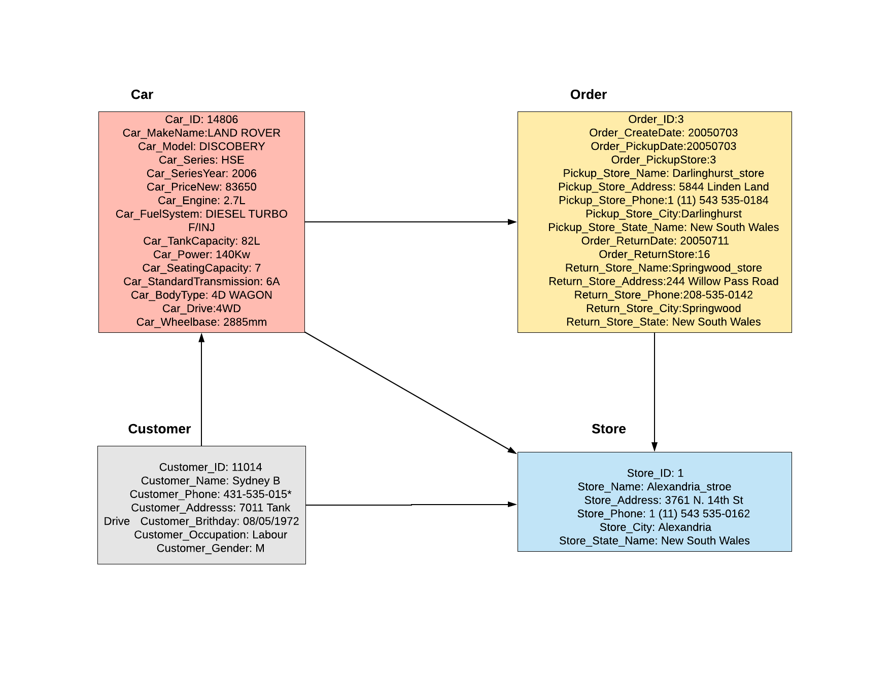

**Artefact 4** – Entity relationship diagram (ERD)

An entity relationship diagram (ERD) shows the relationships of entity sets stored in a database. An entity in this context is a component of data. In other words, ER diagrams illustrate the logical structure of databases. ("Entity Relationship Diagram (ERD) - What is an ER Diagram?", 2018)

It helps developer create the database server by using SQL, it analyse existing databases to find and resolve problems in logic or deployment and represent the entity framework infrastructure.

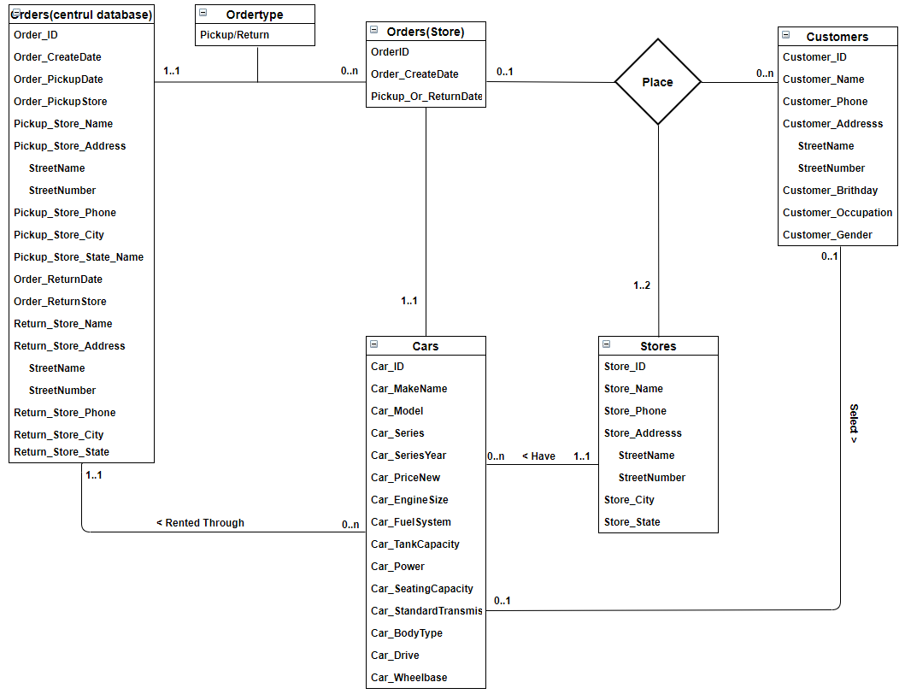

**Artefact 5** – Burndown chart

A time line that presents working process and calculate the estimate time and actual cost time

It remind us of the progress of work, how much time we left and give us a view about our efficiency, when actual tasks line is above ideal tasks line ,then it means we have to work on project more and spend more time on it other wise we cannot achieve our goal

